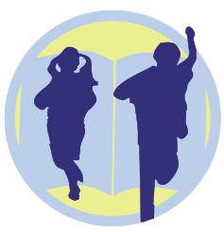
WE ARE LOOKING FOR HIGH QUALITY EARLY CHILDHOOD EDUCATORS!

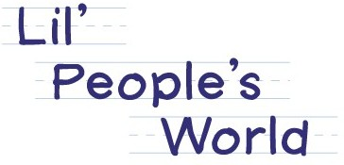

We have a great team of people working together building an amazing community of educators. We are looking for team players who are enthusiastic, flexible, patient, and love working with young children.
Do you have experience with the following?
*Nurturing positive relationships with children and families
*Implementing curriculum *30 Hour STARS training
*CPR/ First Aid/ Blood Bourne Pathogen Training *TB Test
*Experience in classrooms *ECE or CDA classes current or received
Please send resume to:
Seattle-bobbie@lilpeoplesworld.com or jenee@lilpeoplesworld.com
Bellevue- Jessica@lilpeoplesworld.com or whitney@lilpeoplesworld.com
Kirkland- Jamie@lilpeoplesworld.com or dalya@lilpeoplesworld.com.
Lynnwood- fran@lilpeoplesworld.com or miranda@lilpeoplesworld.com

